Expanding Locally
Start a Kinderdance business in your community!
We train you. You don’t have to be a dancer to be a Kinderdance® franchisee!
At our franchisee training, you learn not only how to teach our programs and run a business
but also how the Kinderdance programs teach children how to learn.

Kinderdance is looking for early childhood educators who would enjoy owning a low cost children’s franchise.

Kinderdance® is the original developmental Dance, Motor Skills, Gymnastics, Music and Fitness Programs that combine academic readiness skills specifically designed for children ages 2 to 12, taught on –site in child care facilities in your community. Take control of your life and make a positive difference in the lives of young children in your area by becoming a Kinderdance® franchisee.

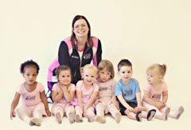
No dance experience required!
Low Investment - Low Overhead
Free Hotel and Airfare during training
Simple business procedures
Exploding customer demand
Recession Resistant
Comprehensive training
And adorable customers!

Why should you become a Kinderdance® franchisee?
Kinderdance® is the largest and fastest growing "Education through Dance, Motor Development, Gymnastics, Music and Fitness" program for young children today.
As a Kinderdance® franchisee you become part of the preschool experience, yet retain your independence. You are free to set your own schedule and your own hours. You can even carry a small inventory of our customized dancewear to generate extra income. Without a studio to support you are nearly free of overhead expenses.
Supplies and On-Going Support: From leotards to business cards, from music to business forms, Kinderdance® provides an initial supply of over 70 items you will need to start your business.

There are choices with Kinderdance®
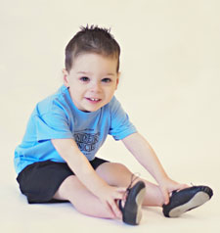
BRONZE - $12,000 - Designed for the person who wants to teach all the classes by themselves on a
part-time or full-time basis. Each Bronze Level franchisee is authorized to teach in up to 10 locations* within their area.
SILVER - $20,000 - Designed for people who want to teach the Kinderdance® programs themselves or with a teacher on a full-time basis. Each Silver Level franchise is authorized to teach in up to 20 locations* in their area.
GOLD - $30,000 - Designed for people who want to market and train others. This gives you unlimited locations in an exclusive territory of up to a 400,000 population (determined by city, county, or zip code boundaries). You may or may not teach the program yourself.

Own the best franchise in child education and motor development!

If you're anxious to get the process going to become a Kinderdance franchisee please feel free to contact me immediately at 800-554-2334 or via email at karenmaltese@kinderdance.com. For more information about franchising with Kinderdance please visit our website at www.kinderdance.com. To start the process you can complete a franchise application by opening this link at Kinderdance Franchise Application.

Sincerely,
Karen Maltese
VP of Franchise Development
Kinderdance International www.kinderdance.com.

